**National University of Computer & Emerging Sciences**

**Karachi Campus**



**Urban Management**

**Project Report**

**DataBase Systems CS2005**

**Submitted on: 22th Dec 2021**

**Section: 5A**

**Submitted to: Sir Muhammad Danish Khan**

**Group Members**

**19K-1299 Syed Muhammad Danish**

**19K-1317 Salman Mehmood**

**19K-0300 Muhammad Rasan**

**Introduction:**

Our project is a web based event management system. It comprises of 6 entities and 1 weak entity. This project was designed to use it in organizing small scale to large scale events. The basic purpose was to get the event’s data in an organized manner, as there is no proper system to validate and regulate event guest’s data in small scale events and gather all the artist and venues detail which we can use in our further events. From this data we can further perform business analysis and other statistics.

This system’s entities are as follows:

* Event_details
* User_details(Client)
* Guests
* Special Guests
* Artists
* Sponsors

First is the Client panel(User_details in DB) where we add, update and delete clients data. Here client can add,update or delete and view events,venue,artists and sponsor. Second is Guest Panel where guest has login/signup and can book events. There he/she can enter the coupon if they are the special guests invited by artist to be listed in Special Guests list. Third Is the Admin Panel. Here admin can view whole data. All Client’s Data, All Events, Guests list, Special Guest list, Venues, Sponsors

There are only two changes that we made in ER. One was the associative table that was missing in ER and the second relation that was corrected was sponsor to event relation which we first kept 1:1 and than changed to 1:N assuming that 1 sponsor can sponsor many events and 1 event can be only sponsored by one sponsor.

<https://drive.google.com/drive/folders/1qkWZRi7Uqjc7EBj4GPxHAGA44JM-rpSw?usp=sharing>

**ER Diagram**

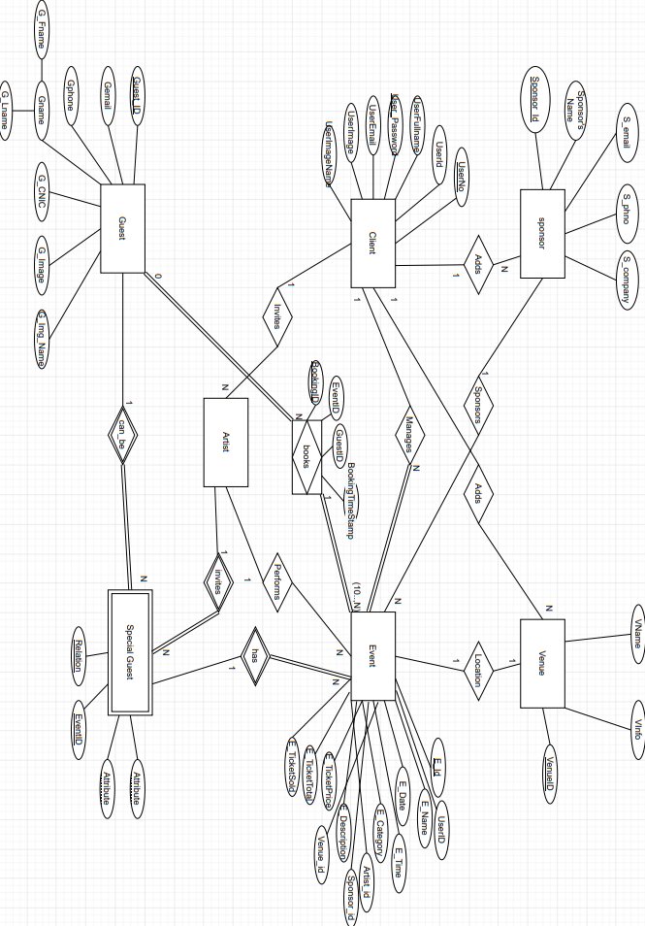

**Table Diagram:**

